Practical - 12
Practical Title:Event Management CRUD with Poster Upload and File Validation
Develop event management functionality for admin users. Admin can add,
view, update, delete, and upload event posters with file type and file size
validation.

Theory
1. Are add, update, and delete functionalities implemented correctly?
Yes, all core record management operations, adding new entries, modifying existing records, and removing data are fully functional and execute proper SQL operations on the backend.
2. Is the UI linked with the database correctly?
Yes, the front-end user interface dynamically fetches, renders, and submits form data to and from the database, ensuring real-time synchronization between the UI and backend storage.
3. Are poster uploads validated for type and size?
Yes, file upload handlers inspect image extensions (e.g., JPG, PNG) and file size limits on submission before moving files to the server directory.
4. Are success and failure messages displayed?
Yes, clear user feedback is provided through alert messages or inline status banners indicating whether an operation completed successfully or encountered an error.

Output
- Connected front-end form controls directly to MySQL database endpoints to manage seamless record creation, updates, and deletions.
- Implemented strict file validation routines on image uploads to verify permitted file extensions and enforce file size restrictions.
- Integrated responsive user feedback alerts to clearly report backend query execution status and error notifications.

To View Code: https://github.com/shreyajodhani/studenthub.git

Evidence of Work (Screenshots)

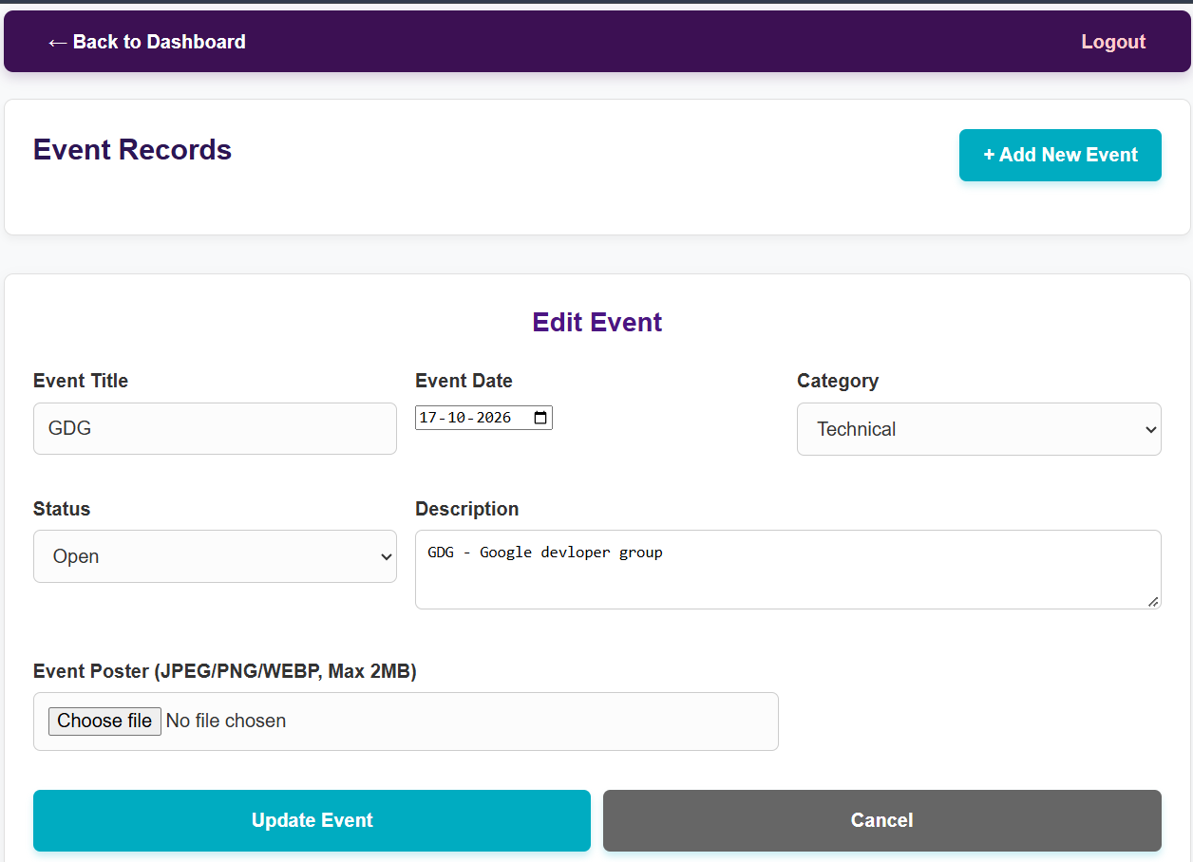
Description: Admin page to add new event, and edit or delete.

GitHub Repository Link: https://github.com/shreyajodhani/studenthub.git

Challenges Faced:

To implement all operations.

Learning Outcomes:
Learnt to use CRUD for uploadation.
Faculty Remarks: (Keep this blank for faculty)

